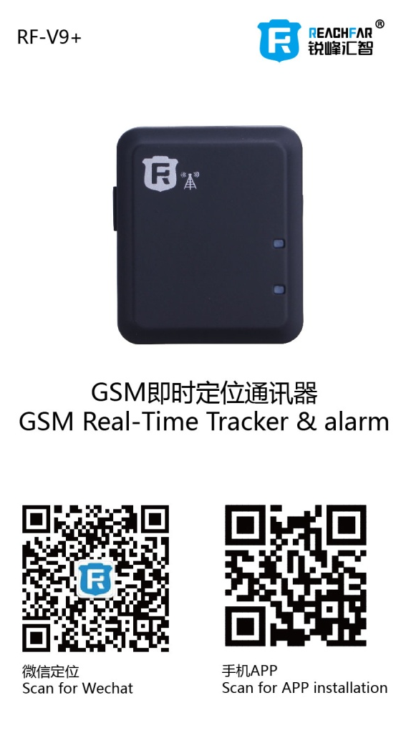
重要提示,请认真阅读
- 本智能门磁报警器是设计用于家居或贵重物品的定位通讯，对侵犯他人隐私的行为概不负责。
- 所有GSM定位相关的产品都会因外在因素产生误差，因此本机提供位置信息仅供参考。
- 因为电信运营商的缘故，在部分情况下，信息传送可能会延迟，本公司对使用者的人身和财产安全免责。
主要功能
- GSM四频 +LBS全球定位
- 苹果/安卓/SMS/网页/微信多维度智能设置与查询
- 震动感应&声音感应即时报警
- 远程收音
- 低电量报警
- 换卡提示
- 超长待机
配件表:
- 主机一台
- USB充电线一条
- 12V 转5V电源一条
- 说明书一本
- 车充一个
产品规格
- GSM频段: 850/900/1800/1900MHz
- GPRS标准: Class 12, TCP/IP
- 工作温度: -20℃ ~ +70℃
- 工作湿度: 5% ~ 95% RH
- 尺寸: 40.0(长)x34.0(宽) x14.0(高)毫米
- 重量: 24克
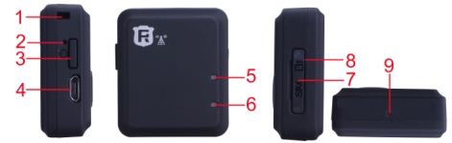
产品示意图:

编号 | 功能 | 编号 | 功能
1 | 挂绳孔 | 2 | 重启复位孔
3 | 开/机关键 | 4 | USB充电口
5 | GSM指示灯 | 6 | GSM指示灯
7 | SIM卡槽胶塞 | 8 | SIM卡槽
9 | 收音孔

第一步：使用前准备
本产品使用GSM网络的Micro-SIM卡(iphone4同类型)。并请注意以下事项:
- 在安装或取出SIM卡前，请先关机；
- 定位通讯器SIM卡需要开通GPRS和来电显示功能.
第二步：安装手机卡及开机
- 请按胶塞上的指示方向插入Micro-SIM卡.
- 按开机键3秒,指示灯亮,开机成功，指示灯由慢闪转为快闪，表示搜网成功．
- 开机状态，按开机键3秒钟，指示亮灯，则关机成功
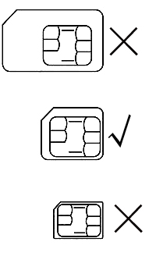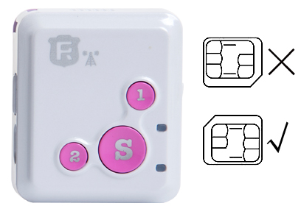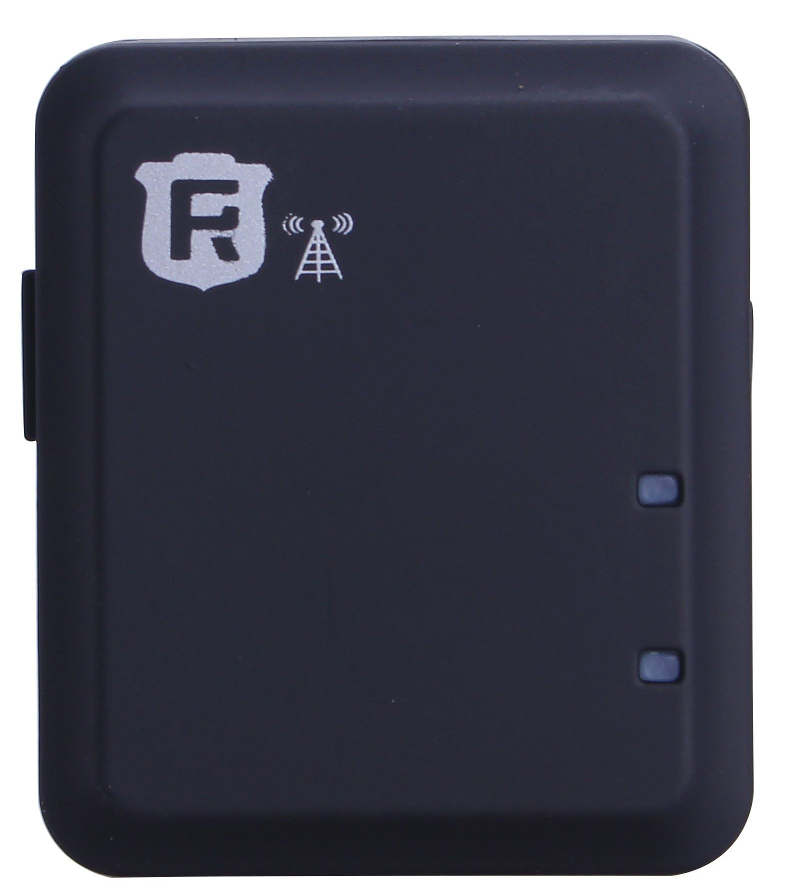

第三步：智能手机APP绑定及功能设置
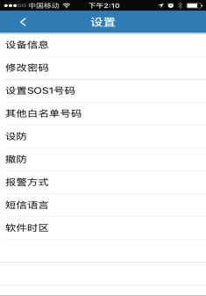
- 扫描说明书封面二维码或苹果商店搜索Reachfar下载手机APP.
- 输入10位数ID号码，初始密码为123456，即可登录．
- 确认设备在线，即可进行对应的指令设置．
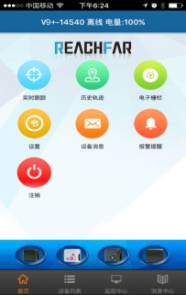
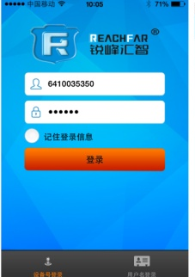

- 功能介绍
- 实时追踪:显示智能门磁最后一次上报的地址位置.
- 历史轨迹:可查看智能门磁的移动轨迹(适用于后备箱防盗
- 电子栅栏:智能门磁被带离设定的位置发出报警(适用于保险箱防盗)
- 指令设置
3.设防/撤防:打开或关闭相关传感器的报警功能.RF-V6+备用三种传感器,可同时工作;
震动感应:受到震动时报警.可以通过短信方式调整震动感应的力度。
声音感应:有异常声响时报警.建议在安静的仓库内使用，以防发生误报。
- SOS1号码:是主控号码,用于发送指令及接收报警信息.
- 白名单号码:远程收听被授权的号码.
- 设防/撤防：打开或关闭相关传感器的报警功能。本产品备用两种传感器，可同时工作；
- 震动感应：受到震动时报警，震动的力度可以通过短信调
- 声音感应：有异常声响时报警，建议在安静的环境下使用声音报警，以免引起误报。
- 防盗报警方式：传感器报警时的方式
- 只上传到平台：当有警情发生时，只通过APP报警。如APP没有登录则不能即时收到报警提示。(只有流量费,不产生其他费用)
- 先短信，后电话再上传平台：当有警情发生时，3种方式全部通知。(会产生相应的短信费和话费)
- 电话和平台报警：当有警情发生时,先打电话并有APP通知。(如果接听电话则会产生话费)
- 短信和平台报警：当有警情发生时,手机短信报警及APP通知。(会产生相应的短信费用)
- 短信语言设置：选择短信报警的语言种类，本产品提供三种语言模式：中文，英文及法语
- 软件时区：APP时间，出厂默认为UTC+8北京时间，如果出国使用可跟据当地时区进行设置。
- 设备信息：显示所有的报警列表.
- 报警提醒:是否接收报警信息的APP推送.
- 注销:退出APP程序,不再接收APP的报警推送,
更多APP及平台详细功能请登录www.rfgsm.net了解!

实时通话
远程收音:用已绑定的SOS号码拔打防盗定位通讯器的号码，即可听到周边的环境声音，应对突发事件。

短信方式设置相关的参数.
所有指令中的字母全部小写,标点为英文标点,并且都以#号为结束符.
绑定SOS1号码:短信指令:密码,sos1,手机号码#
例如:123456,sos1#
或:123456,sos1,180********#
定位通讯器即回复:已设置180********为主控号码。
特别提示:
只有绑定的主控号码后,才能用主控号码进行指令的设置.
注意事项
- 关机状态下,充电将自动开机.
- 请将本品安放在网络信号较好的位置使用。
- 新机使用前需充电2-3小时，以达到最佳的效果。
- 待机时间:1)每10分钟上传一次定位信息,待机时间为100小时，通话时间：5-8小时。(实测); 2)关闭定时上传定位信息,待机时间为280小时,约12天.注:以上测试数据来自GSM网络信号强的状态.
- 本机在开机或追踪状态下,搜网不成功或没有插放SIM卡,会自动重启..
常见问题:
- 问:设备插卡后,能接通电话,但是在平台及APP上显示未启用.
答:请确认SIM已经开通了GPRS功能.
- 问:设备已经开通了GPRS功能,但是APP依然显示未启用.
答:因为移动和联通升级3G和4G后针对不同的SIM卡有不同的APN. 可能是预设GPRS的APN参数不正确.请先用短信方式绑定SOS1号码,然后再发送短信指令: 联通卡:apn,uniwap#,重启后依然不上线,则改发:apn,uninet#
移动卡:apn,cmwap#,重启后依然不上线,改发:apn,cmnet#

- 问:设备显示在线,但用APP设置指令时,显示等待设备应答.
答: A.设备信号不良,导致GPRS通讯不畅通;
B.设备正在通话中.
其他短信指令表:
短信指令 | 功能
密码,sos1,号码# | 设置主控号码
sos2（3,4,5）,号码# | 设置sos2号码,其他号码以此类推，总共可以设置4个白名单号码。
von,数字# | 开启震动感应防盗报警功能,数字为1时,灵敏度最高,数字为4时,灵敏度最低.
voff# | 关闭震动感应防盗报警功能.
non# | 开启环境声音感应报警功能.
noff# | 关闭环境声音感应报警功能.
ntim,数字# | 设置声音感应报警延时时间.
mod,数字# | 设置防盗报警的报警方式,1为先发短信再打电话(出厂默认.);2为只打电话;3为只发短信.
dw# | 短信查询定位通讯器位置
dsp# | 查询设备工作状态
lag,1# | 系统语言转为中文.(出厂默认)
lag,2# | 系统语言转为英文.
lag,3# | 系统语言转为法文.
gon# | 开启实时定位功能 (出厂默认)
goff# | 关闭实时定位功能.
旧密码,t,新密码# | 更改密码,出厂密码123456
User Manual
Real Time tracker & alarm

Important, please attention:
- This real time tracker & alarm was designed for home and asset location and communication, our company assumes no liability or responsibility for any behaviors violate other individual’s privacy.
- Due to external factors all GSM devices have position error, so the position provide by this device just for reference only.
- There may be delays caused by telecom operators at certain circumstance. Our company doesn’t assume liability for users’ personal and property safety

Main Features:
- GSM quad band network, LBS location
- Website/IOS APP/Android APP/SMS ;multiple set and tracking
- Noise sensor alarm
- Vibration sensor alarm
- Noise monitoring
- Low battery alarm
- SIM changing alarm
- Long time standby

Product specification:
GSM network: 850/900/1800/1900MHz
GPRS standard: Class 12, TCP/IP
Working temperature: -20℃ ~ +70℃
Working humidity: 5% ~ 95% RH
Host size: 40x34 x14mm
Host weight: 24g

Accessories
1* Main Host
1* USB cable
1* User manual
1* 12V to 5V power supplier
1* Car charger
Product View:

NO | Function | NO. | Function
1 | Lanyard hole | 2 | Reset hole
3 | Switch button | 4 | Charger hole
5 | GSM indicator | 6 | GSM indicator
7 | Slot rubber plug | 8 | SIM slot
9 | Microphone

Step 1: Prepare for work:
Please choose GSM network-based Micro-SIM card (same as Iphone4) for the product. And please note:
a. Please be sure the tracker is turn off before insert or take out the Micro-SIM.
b. Please be sure the GPRS and Caller ID has been activated

Step 2: Power on
Press power button 3S, when indicator flash it means power on, when indicator light flash fast it show s that the tracker search network successfully

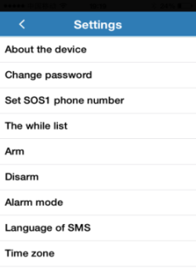
Step3: APP binding and function setting:
- Scan the User manual cover QR code or search the Reachfar in App store & Google play store to install the App.
- Enter the ID number and password to login, the default password is 123456.
- Confirm the device online, the corresponding instruction set can be achieved
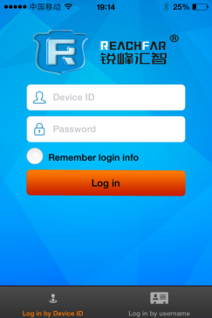
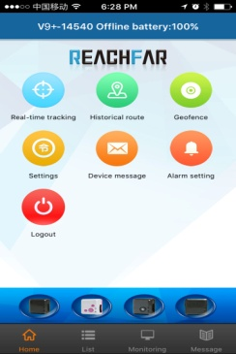

- APP Introduction
- Real-time Tracking: show the last position and trace.
- Historical route: display the historical.
- Geo-fence: set and display Geo-fence area, when the device gets into or get out the Geo-fence then it will send an alert SMS.
- Command setting
- Device info: check and mark the device information.
- Change password: change the App and web login password.
- SOS1 phone number: The master phone number, used to send command and receive alarm.
- White list number: the other SOS number, also allow to remote listening.
- Arm/Disarm: open or close related sensor alarm function. there are 2 sensors , they can work at the same time;
- Vibration sensor:
When the device detects
Trembled, it will alarm.
- Noise sensor: when the device detects the noise, it will alarm. Please use the noise sensor alarm in quite area to reduce the false alert.
- Alarm mode:
- Alert to APP: only through the APP alarm. You can't receive alarm notification if you don't login.(Only GPRS fee, no other charge)
- Alert to SMS, phone and APP: The device will send SMS and APP alert first and then make call notification(it will charge calling and SMS fee)
- Alert to phone and APP: The device will call you and send APP notification(Call charges )
- Alert to SMS and APP: The device will send SMS and APP alert(SMS charge)
- Language of SMS：Choose SMS language, the device provide three languages: Chinese, English and French
- Time zones：It is for App time setting, the factory default is UTC+08:00; users can set it according to local time zone.
- Device message: display the alert list.
- Alarm setting: get the remind via APP when alarm
- Logout: logout the APP, and never get the alarm remind via APP

Please log on www.rfgsm.net to learn more details of APP and platform

Remote listening function
In responding to emergency, rapid-dialing the binding SOS number to this tracker can successfully hearing surrounding voices.

All functions also can set by SMS command
All command use in lowercase letters, without any blank space and ending by #.
Command for setting master number:
password,sos1,phone number#
For example:123456,sos1,180********#
The tracker will reply: 180******** has been set for the master number successfully.
Note:All SMS setting must send via SOS1 number.

Remark:
1. The tracker will boot automatically when it was charging. Please put the tracker in network signal better position when use.
2. The new machines need to be recharged for 2-3 hours before use in order to achieve the best results.
3. Standby time:
1) Upload location data every 10 minutes, the standby time is 100 hours, talking time is 5-8 hours (Actual test)
2) Close the real time tracking function ,it can be standby 280hours(about 12days)
Note: Above test data is under the status of strong GSM network
- Please charging and boot with SIM card, the device will automatically reboot when it can’t search GSM network.
5. This product is not waterproof, please pay attention when using.

FAQ
Q: After inserting a SIM card, it can make a call, but it display not enable on the platform and APP?
A: Please check that SIM Card has activated the GPRS data plan.

Q: The SIM card has activated GPRS data plan, but the device still not online.
The tracker have pre-program all most APN, maybe the APN of the SIM card you use don’t preset in the tracker, please find the apn data from the SIM card company ,then send command to add the apn data into the tracker.
The command is: apn,apndata#

Q: When I make call to device from white list number, why it is not auto-answer my call?
A: Please check that SIM Card has activated the caller ID.

Q: Device show online, but it shows “wait for the device responses” when you set instruction with APP.
A: a. Device signal is not good, so not smooth result of GPRS
b. Device is busy.

Command | Function
password,sos1,phone number# | Set master-control phone number
sos2(3,4,5), phone number# | Set sos2(3,4,5) phone number
gon# | Turn on real time tracking function
goff# | Turn off real time tracking function .
von,digital# | Turn on the vibrating sensor burglar alarm( level 1 is the most sensitive and level 4 is the least sensitive)
voff# | Turn off the vibrating sensor burglar alarm
non# | Turn on the noise sensor burglar alarm
noff# | Turn off the noise sensor burglar alarm
ntim,digital# | Set the noise sensor burglar alarm lasting time
mod,digital# | Set the method of burglar alarm,1phone calls&messages,2only phone calls,3only messages
dw# | Inquiry positioning by SMS message
dsp# | Inquiry tracker’s situation
lag,1# | Change the language to Chinese(factory default)
lag,2# | Change the language to English
lag,3# | Change the language to French
Password,t,password# | Change the password, the factory default password is 123456

Command for SMS setting

